JIRA

JIRA is a product of [www.atlassian.com](http://www.atlassian.com), which is a tool used for issue tracking and bug tracking and for Project Management. JIRA has its own database HSQLDB, but as per our project plan we are using MySQL as part of the database to store the JIRA data, which can be extracted using JQL (JIRA Query Language).

JIRA as a Project Management tool has 2 modes Kanban and Scrum.

Scrum and Kanban are two terms that are often (incorrectly) used interchangeably or thought to be two sides of the same coin. In reality, there are significant differences between these two Agile methodologies. Scrum is a tool used to organize work into small, manageable pieces that can be completed by a cross-functional team within a prescribed time period (called a sprint, generally 2-4 weeks long). To plan, organize, administer, and optimize this process, Scrum relies on at least three prescribed roles: the Product Owner (responsible for initial planning, prioritizing, and communication with the rest of the company), the Scrum Master (responsible for overseeing the process during each sprint), and the Team Members (responsible to carry out the purpose of each sprint, such as producing software code.) Another common tool used by scrum teams is the Scrum Board – a visual representation of the work flow, broken down into manageable chunks called “stories”, with each story moved along the board from the “backlog” (the to-do list), into work-in-progress (WIP), and on to completion. [Kanban](https://www.cprime.com/training/onsite/kanban/) is also a tool used to organize work for the sake of efficiency. Like Scrum, Kanban encourages work to be broken down into manageable chunks and uses a Kanban Board (very similar to the Scrum Board) to visualize that work as it progresses through the work flow. Where Scrum limits the amount of time allowed to accomplish a particular amount of work (by means of sprints), Kanban limits the amount of work allowed in any one condition (only so many tasks can be ongoing, only so many can be on the to-do list.).

Both Scrum and Kanban allow for large and complex tasks to be broken down and completed efficiently. Both place a high value on continual improvement, optimization of the work and the process. And both share the very similar focus on a highly visible work flow that keeps all team members in the loop on WIP and what’s to come.

Example for Scrum Board:

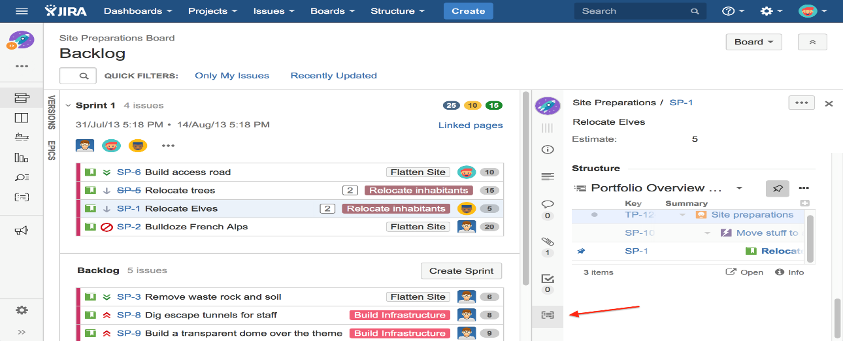

Example for Kanban:

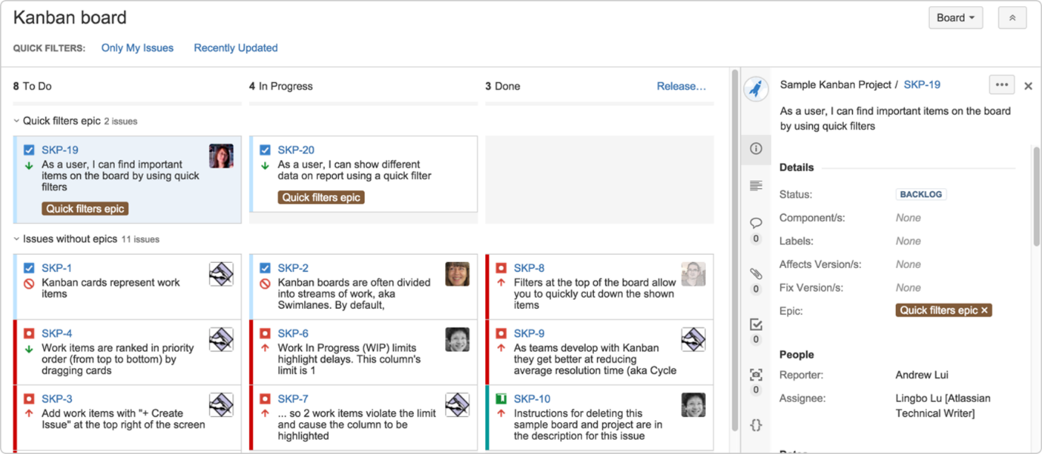

Features of JIRA:

[Because you've got issues](http://www.atlassian.com/software/jira/features/default.jsp)

JIRA lets you priorities, assign, track, report and audit your 'issues,' whatever they may be — from software bugs and help-desk tickets to project tasks and change requests.

[Reporting and statistics](http://www.atlassian.com/software/jira/features/report.jsp)

Customizable reporting allows you to monitor the progress of your issues with detailed graphs and charts.

[Workflow your way](http://www.atlassian.com/software/jira/features/workflow.jsp)

Map your business process with a custom workflow.

[An extensible platform](http://www.atlassian.com/software/jira/plugins/default.jsp)

Integrate JIRA into your systems with our open API and 100+ free plugins.

JIRA 6.4.7 INSTALLATION with Port no-8091

==================

cd /opt/software/jira/

wget https://www.atlassian.com/software/jira/downloads/binary/atlassian-jira-6.4.7-x64.bin

chmod +x atlassian-jira-6.4.7-x64.bin

./atlassian-jira-6.4.7-x64.bin

//do change the JIRA port no to 8091 in /opt/software/jira/atlassian-jira-6.4.7/conf/server.xml

Service jira start

<http://server-ip:8091>

MySQL installation

===================

wget https://dev.mysql.com/get/mysql57-community-release-el7-9.noarch.rpm

rpm -ivh mysql57-community-release-el7-9.noarch.rpm

yum install mysql-server

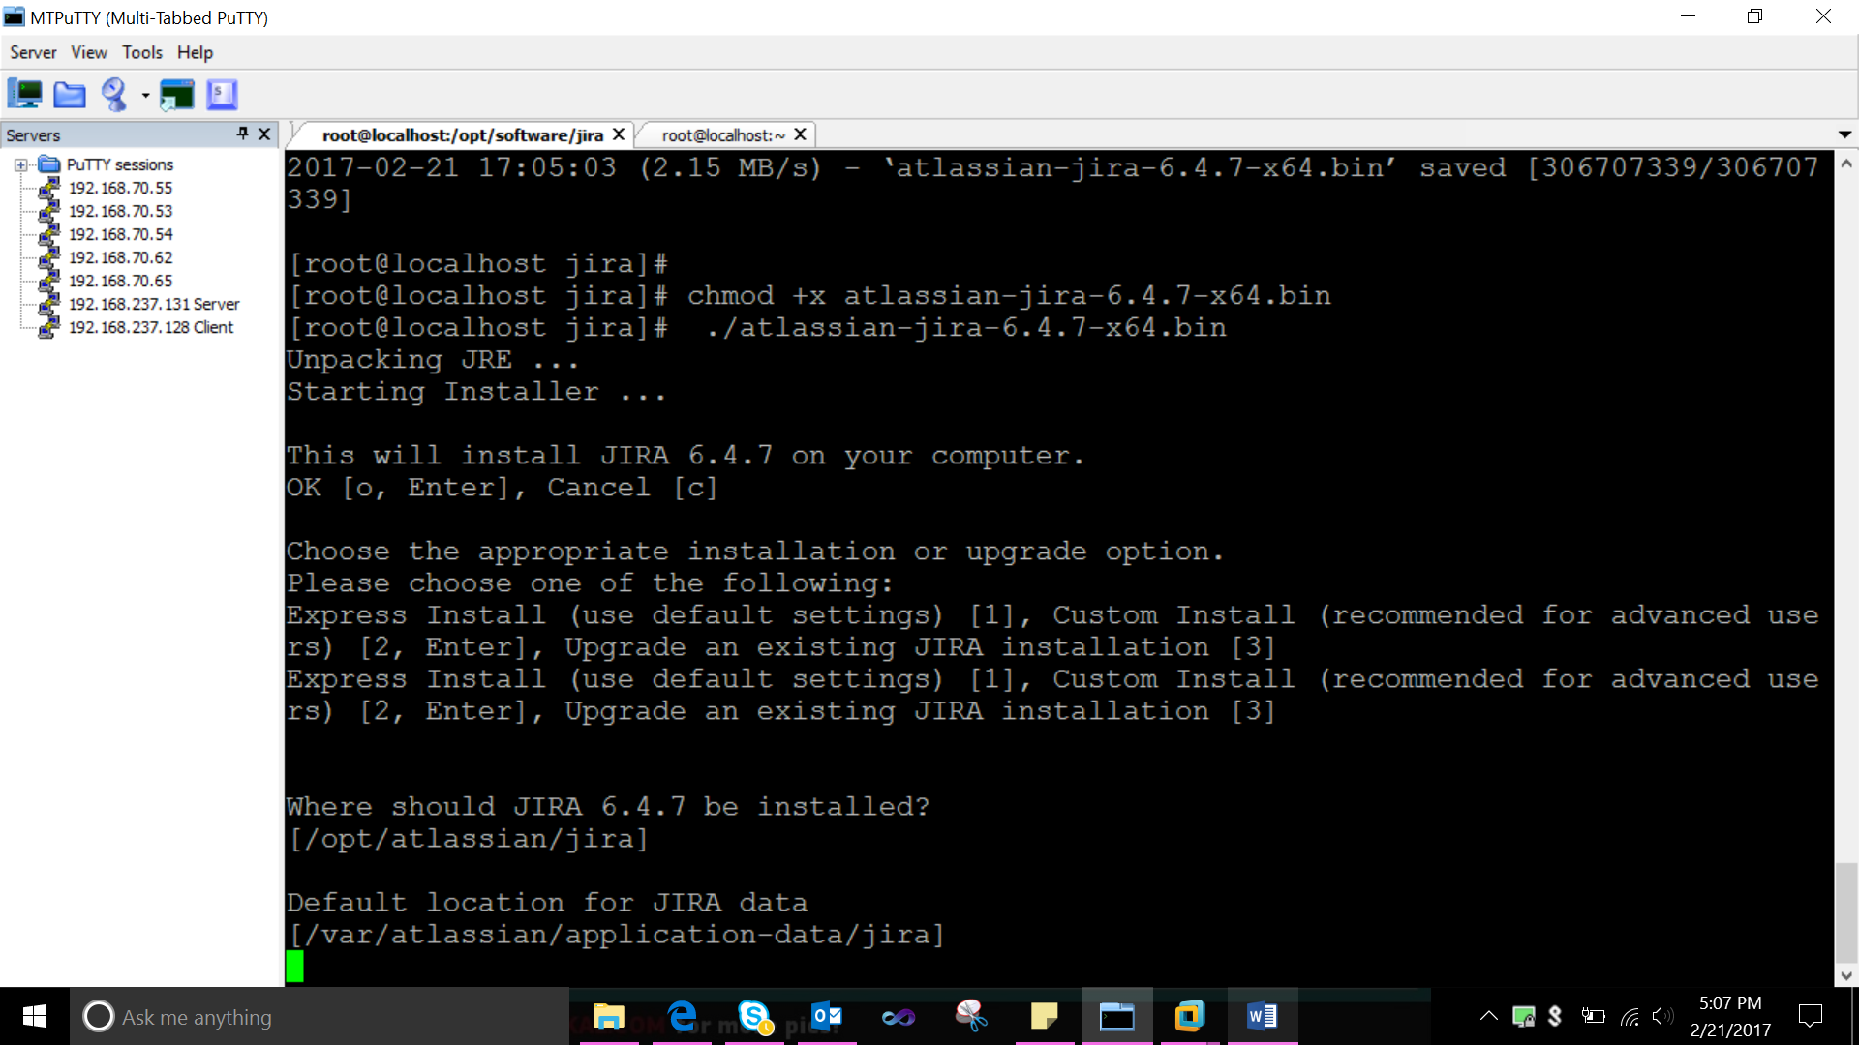

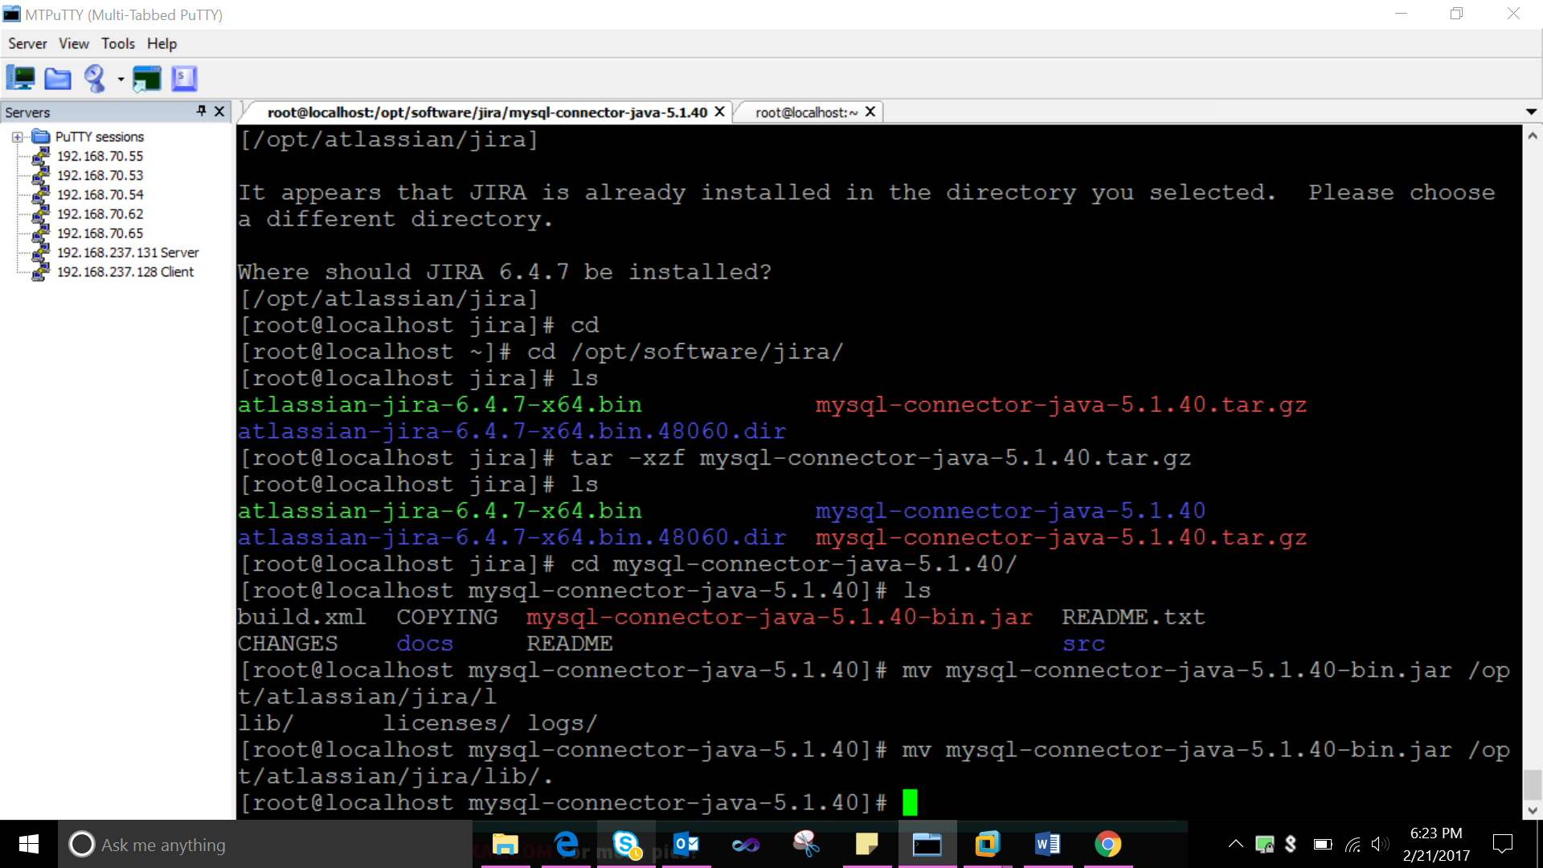

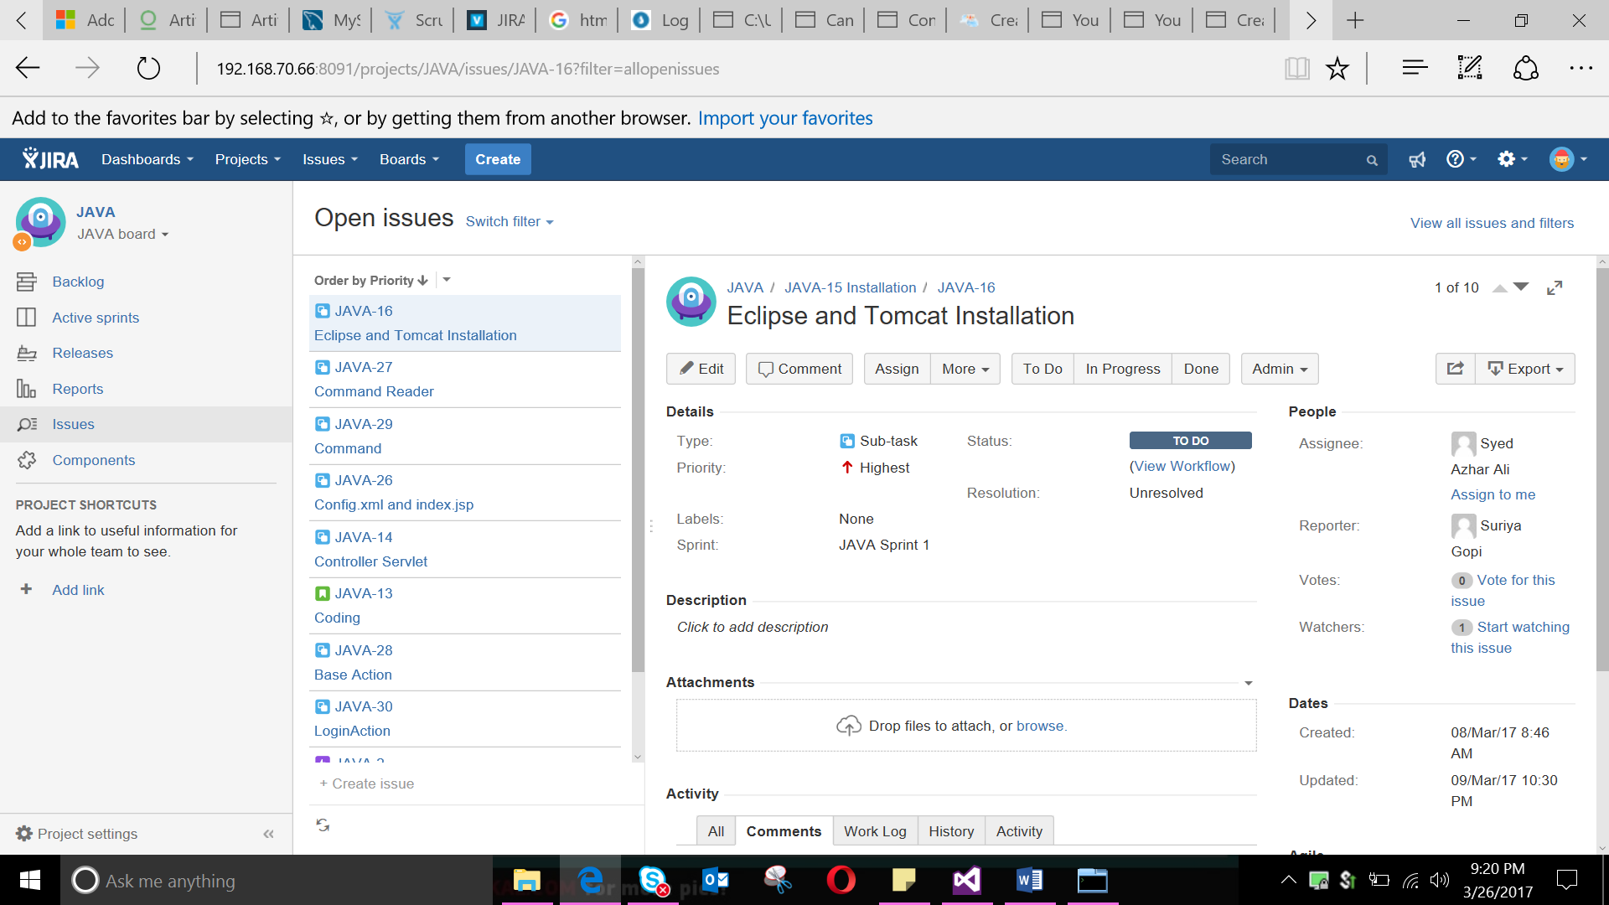

JIRA Terminologies (Few):

|  |  |  |  |
| --- | --- | --- | --- |
| Epic Large body of work, contains stories | Story Smallest unit of work, also known as a task | Tasks A unit of work contained within a story | Subtask used to split up a parent task into a number of tasks which can be assigned and tracked separately. |

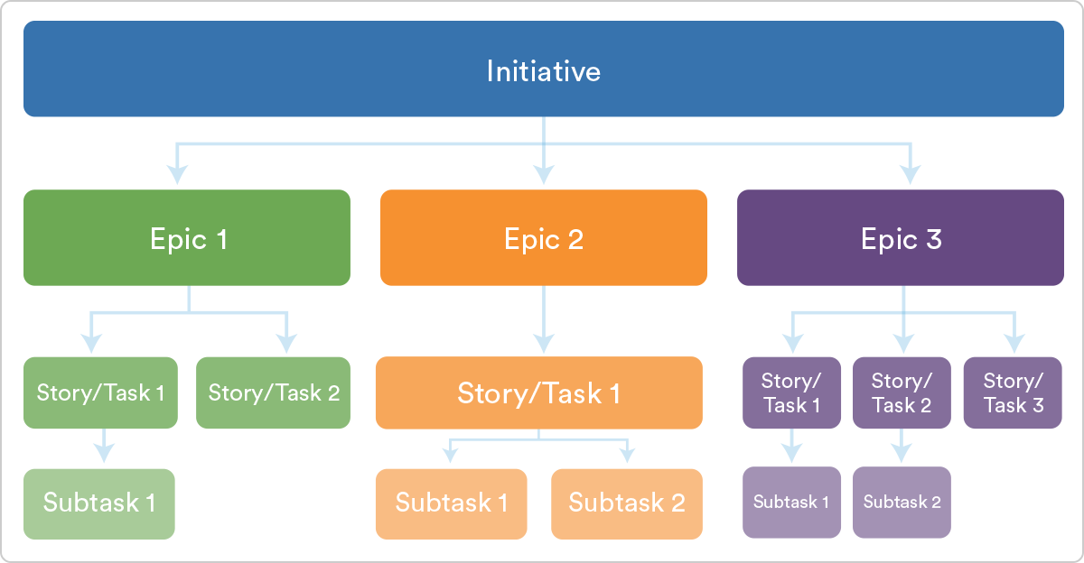

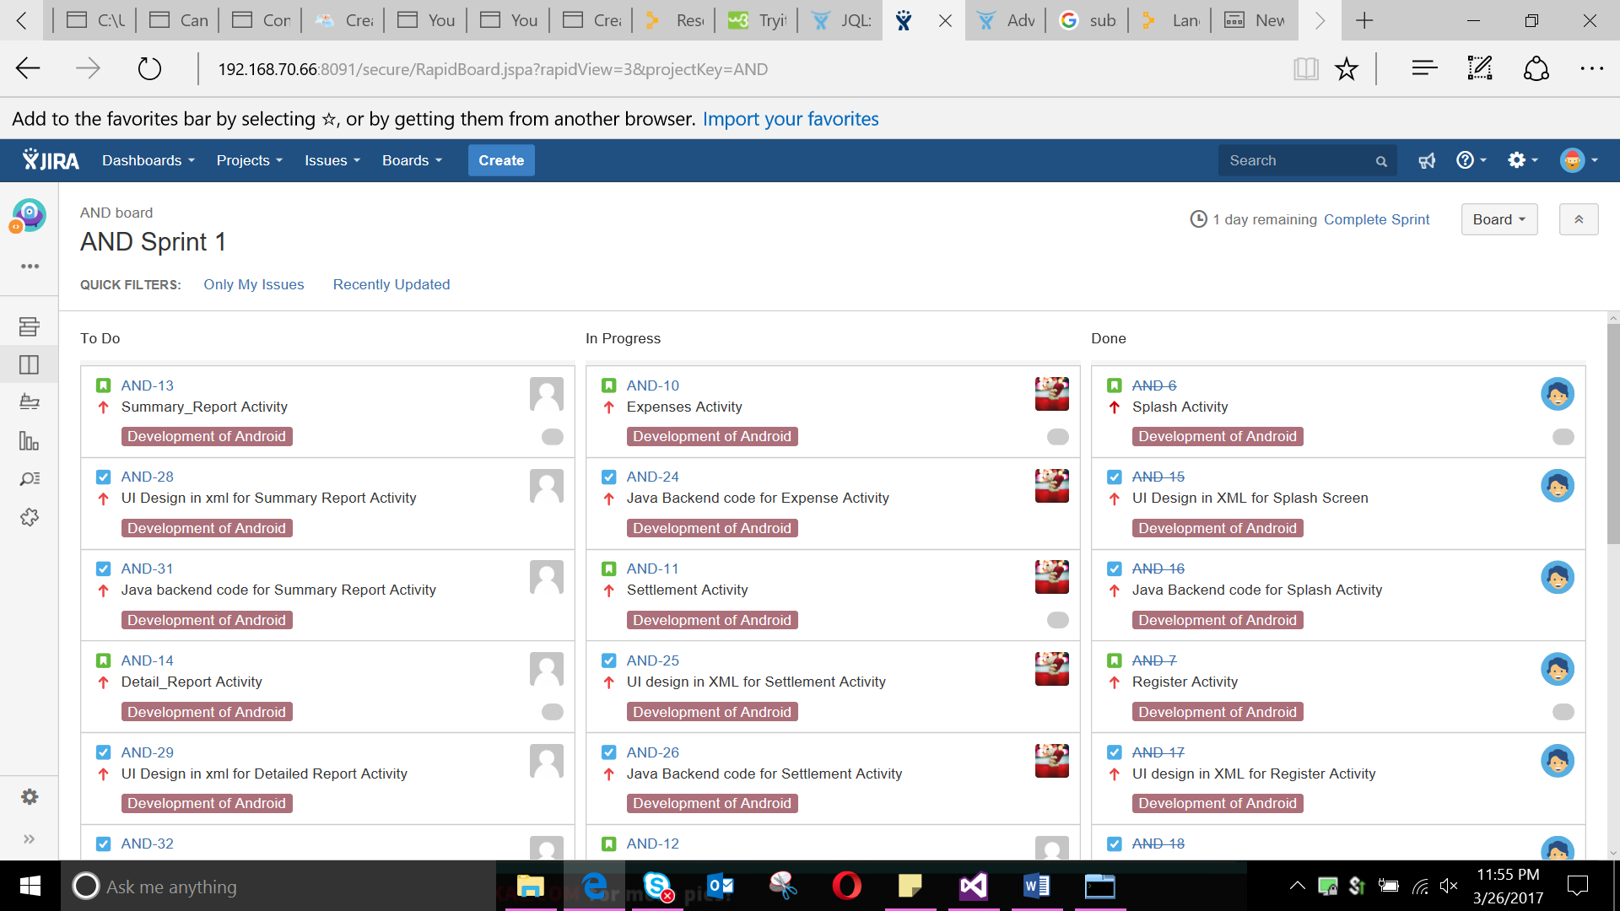

JQL (JIRA Query Language)

The advanced search allows you to build structured queries using the JIRA Query Language (JQL) to search for issues. You can specify criteria that cannot be defined in the quick or basic searches (e.g. ORDER BY clause). Note: JQL is not a database query language, even though it uses SQL-like syntax.

* If you don't have complex search criteria, you may want to use [quick search](https://confluence.atlassian.com/jirasoftwarecloud/quick-searching-764478325.html) instead.
* If you are not comfortable with the JIRA Query Language (JQL), you may want to use [basic search](https://confluence.atlassian.com/jirasoftwarecloud/basic-searching-764478306.html) instead.

A simple query in JQL (also known as a 'clause') consists of a field, followed by an operator, followed by one or more values or functions.

Fields- A field in JQL is a word that represents a JIRA field (or a custom field that has already been defined in JIRA).

Operators- An operator in JQL is one or more symbols or words that compare the value of a field on its left with one or more values (or functions) on its right, such that only true results are retrieved by the clause. Some operators may use the NOT keyword.

Keywords- A keyword in JQL is a word or phrase that does (or is) any of the following:

* joins two or more clauses together to form a complex JQL query
* alters the logic of one or more clauses
* alters the logic of operators
* has an explicit definition in a JQL query
* Performs a specific function that alters the results of a JQL query.

Functions- A function in JQL appears as a word followed by parentheses, which may contain one or more explicit values or JIRA fields.

A function performs a calculation on either specific JIRA data or the function's content in parentheses, such that only true results are retrieved by the function, and then again by the clause in which the function is used.

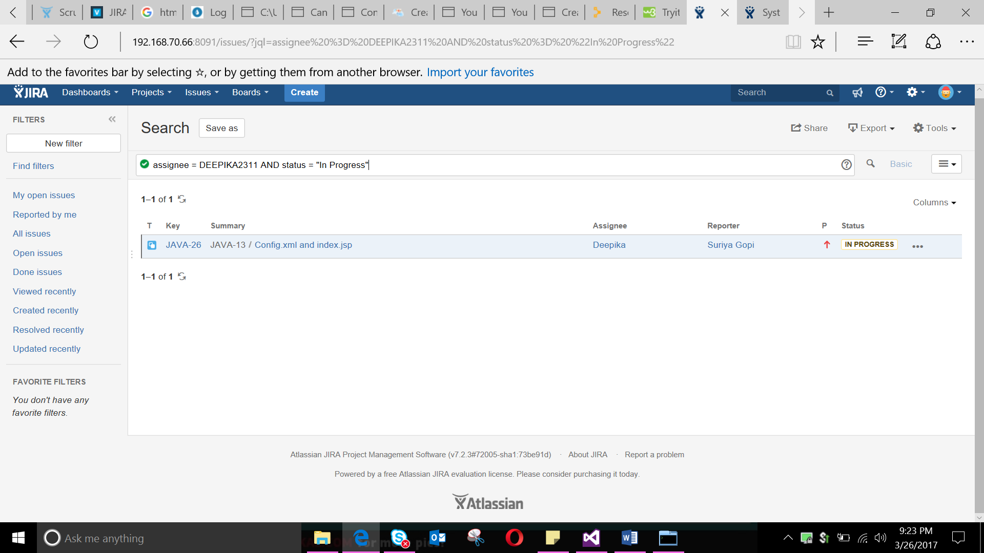

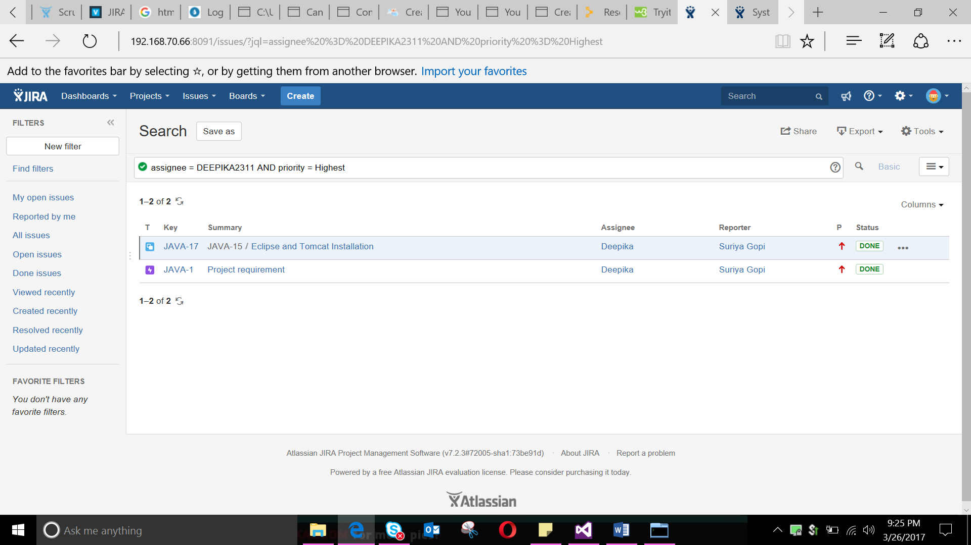

Bibliography:

https://confluence.atlassian.com/jira/jira-documentation-1556.html

<https://confluence.atlassian.com/jirasoftwarecloud/advanced-searching-764478330.html>

https://www.atlassian.com/blog/jira-software/jql-the-most-flexible-way-to-search-jira-14